1 Background 1
2 Using this document 1
3 Hierarchical Structure 1
4 File Information 5
RECID 00 File Information Record 5
5 Sampling Location Records 5
RECID 90 Sampling Platform Record 5
RECID 91 Station / Sampling Event Record 6
RECID 92 Station / Site Description Record 7
6 TRANSECT Record 7
RECID 40 Transect Description Record 7
7 Sample Records 9
RECID 03 Contaminant, Biological Effects and Litter Sample Record 9
RECID 34 Biological Community and Litter Sample Record 11
RECID 04 Biota Specimen Data Record 12
8 measurement records 13
RECID 10 Parameter Measurement Record 13
RECID 36 Litter Record 15
RECID 38 Biological Community Abundance/Biomass Record 16
9 Method RecordS 17
RECID 20 Sampling Method Record 17
RECID 21 Analytical Method Record 19
10 Quality Assurance (QA) Records 21
RECID 93 Reference Material Record 21
RECID 94 Intercomparison Record 21
11 SUPPORTING INFORMATION 22
12 CHANGE LOG 24

Background
ICES has been asked to support the reporting of environmental data in an integrated reporting format ensuring that the various scientific requirements for specific data types are covered while allowing standardised reporting of common meta data for these data. The format and underlying quality control procedures are designed to ensure comparable and relevant data for international assessments. The requirements in this document have been specified by various Expert and Assessment groups.
This format can be used to report data on: contaminants, biological effects of contaminants, and fish disease in biota (data type CF), contaminants and biological effects in sediment (data type CS), and contaminants, biological effects and ocean acidification in seawater (data type CW). It also allows reporting of biological community data for phytoplankton (data type PP), zooplankton (data type ZP), phytobenthos (data type PB) and zoobenthos (data type ZB). The newest record in the reporting format allows the reporting of litter (data type LT). Litter can be reported as an addition to existing data types files (for example microplastics in stomachs or sediment fractions) or as a data type reported separately on its own (for example, trawl litter data).
This format provides a common entrance to the ICES database DOME which utilizes a common top level structure based on position and time. The reporting format is Version 3.2.5 of the ICES Environmental Data Reporting Formats.

Using this document
Not all records and fields are mandatory for entering data into the DOME database. Only fields marked “M” are mandatory for DOME. However, the data submitter should check Commission guidelines (HELCOM, OSPAR) since additional fields are mandatory for certain Commission monitoring programmes. These are not reflected in this document. Some fields are marked “r” for recommended to bring these to the users’ attention. This document (and the data submissions created through the use of this format) has been designed for use in connection with a number of web-based facilities.

Links to resources:
http://vocab.ices.dk/ | Reference codes are found here, i.e. valid lookup codes for the reporting format fields
http://dome.ices.dk/datsu/selrep.aspx | Valid fields and checks according to each data type
http://vocab.ices.dk/?sortby=Description&ref=90 | List of recommendations from Commissions and Working Groups can be found in “MPROGinfo” (see Monitoring Programme information)
http://dome.ices.dk/datsu/ | Data screening programme
http://www.ices.dk/marine-data/guidelines-and-policy/Pages/default.aspx | Commissions and ICES TIMES guidelines
http://ices.dk/marine-data/tools/Pages/Submission%20status.aspx | Track the progress of a data submission
http://www.ices.dk/marine-data/data-portals/Pages/DOME.aspx | DOME portal information
http://dome.ices.dk/browse/index.aspx | View and download submitted files
http://dome.ices.dk/views/ | Search DOME with specific filters

Hierarchical Structure
This format is based on a hierarchical structure which is illustrated in the diagrams below. Note that the diagram does not specify actual hierarchy for QA records.
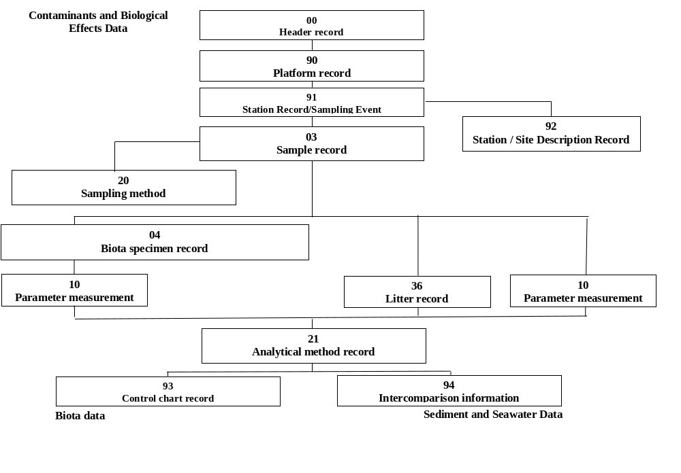
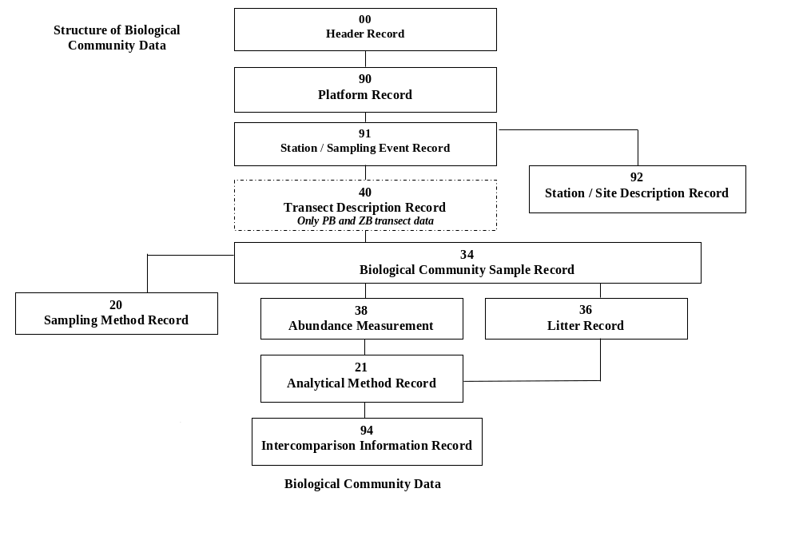
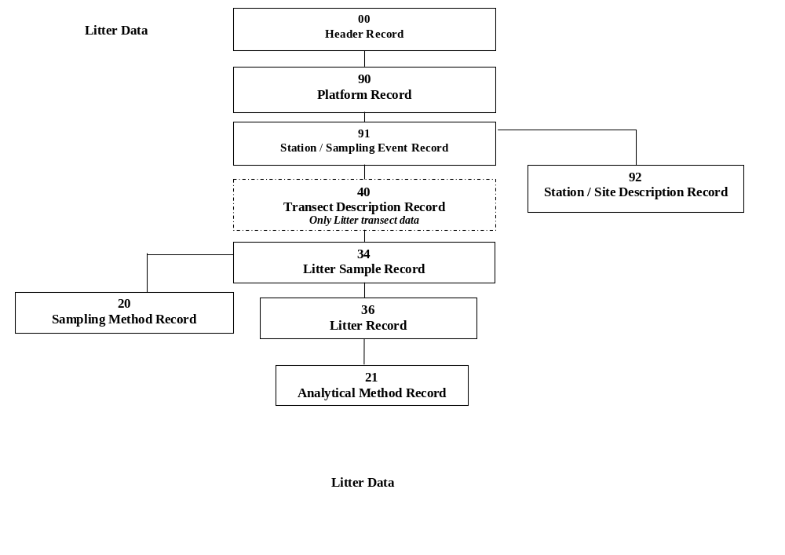

File Information

RECID 00 File Information Record
File Information Record
– mandatory record –
Field Code | Field Name | Valid Value | Mandatory/  Recommended/  Optional
RECID | Record identifier | ‘00’ | M
RLABO | Reporting institute code | cf. RLABO | M
CNTRY | Country code | cf. CNTRY | M
MYEAR | Monitoring year | YYYY | M
RFVER | Reporting format version number | ‘3.2.5’ | M
DCFLG | Data centre flag - Reserved

Sampling Location Records

RECID 90 Sampling Platform Record
Sampling Platform Record
– mandatory record –
Field Code  Foreign key in bold, primary key in italics | Field Name | Valid Value | Mandatory/  Recommended/  Optional
RECID | Record identifier | ‘90’ | M
SHIPC | Platform / Ship code | cf. SHIPC | M
CRUIS | Cruise identifier (series of sampling occasions)  (must be unique for file) | Any character 0–9, A–Z etc. | M
Owner | Data owner | Any character 0–9, A–Z etc. | R
PRDAT | Public release date | Date YYYYMMDD | R
DCFLG | Data centre flag - Reserved

RECID 91 Station / Sampling Event Record
Station Record
– mandatory record –
Field Code  Foreign key in bold, primary key in italics | Field Name | Valid Value | Mandatory/  Recommended/  Optional
RECID | Record identifier | ‘91’ | M
CRUIS | Cruise identifier (series of sampling occasions)  (must be unique for file) | Any character 0–9, A–Z etc. | M
STNNO | Station identification /Sampling event ID | Any character 0–9, A–Z etc. | M
LATIT | Latitude (degrees/minutes/decimal minutes or as decimal degrees)  Report as WGS84 | −90 00.000 to +90 00.000 or -90.0000 to +90.0000  cf. Field Code Descriptions | M
LONGI | Longitude (degrees/minutes/decimal minutes or as decimal minutes)  Report as WGS84 | −180 00.000 to +180 00.000 or −180.0000 to +180.0000  cf. Field Code Descriptions | M
POSYS | Positioning system | cf. POSYS multiple options possible (separate multiple entries with “~” (ascii 126)) | R
SDATE | Sampling date | YYYYMMDD | M
STIME | Sampling time/start (UTC) | 0000–2359 (hhmm) | R Fish disease
ETIME | Sampling end time (UTC) | 0000–2359 (hhmm) See field description for handling time when sampling continues to the next day. | R Fish disease
WADEP | Water depth (sounding in meters) | 0–9 | rCW, rZB
STATN | Station name | Any character 0–9, A–Z etc. (max. 50) | R
MPROG | Monitoring programme | cf. MPROG multiple programmes possible  (separate multiple entries with “~” (ascii 126)) | M
WLTYP | Water/land types (river basin/eurotypes) | cf. WLTYP | R
MSTAT | Type of monitoring station cf. Eurowaternet Technical report number 97 | cf. MSTAT (replaces point source)  (separate multiple entries with “~” (ascii 126)) | R
PURPM | Purpose of monitoring | cf. PURPM (separate multiple entries with “~” (ascii 126)) | R
EDATE | Sampling end date | YYYYMMDD | mPassive samplers
DCFLG | Data centre flag - Reserved

RECID 92 Station / Site Description Record
Station / Site Description Record
– optional for CF/CS/CW/PP/PB/ZP/ZB/LT –
Field Code  Foreign key in bold, primary key in italics | Field name | Data type |  |  |  |  |  |  |  | Value | Mandatory/  Recommended/  Optional
RECID | Record identifier | CF | CS | CW | PP | PB | ZP | ZB | LT | ‘92’ | M
CRUIS | Cruise identifier (series of sampling occasions)  (must be unique for file) | CF | CS | CW | PP | PB | ZP | ZB | LT | Any character 0–9, A–Z etc. | M
STNNO | Station identification /Sampling event ID | CF | CS | CW | PP | PB | ZP | ZB | LT | Any character 0–9, A–Z etc. | M
RSRVD | Reserved
MATRX | Matrix analysed | CF | CS | CW | PP | PB | ZP | ZB | LT | “SI” | M
PARAM | Parameter code | CF | CS | CW | PP | PB | ZP | ZB | LT | cf. PARGROUP parameters, for example, S-DES | M
MUNIT | Measurement unit | CF | CS | CW | PP | PB | ZP | ZB | LT | cf. MUNIT | M
VALUE | Value | CF | CS | CW | PP | PB | ZP | ZB | LT | Any format | M
DCFLG | Data centre flag - Reserved | CF | CS | CW | PP | PB | ZP | ZB | LT

TRANSECT Record

RECID 40 Transect Description Record
For the purposes of this format, a transect for benthos data is defined as a straight line from shore/transect start, along the substrate, until the end of vegetation or 30 meter depth. This record is used to describe the whole transect. Sections should not be defined here.
A diagram is available in 11 SUPPORTING INFORMATION to use as a guide.

Transect Description Record
- mandatory for PB/ZB/LT transects -
Field Code  Foreign key in bold, primary key in italics | Field name | Data type |  |  |  |  | Value | Mandatory/  Recommended/  Optional
RECID | Record identifier |  | PB |  | ZB | LT | ‘40’ | M
CRUIS | Cruise identifier (series of sampling occasions)  (must be unique for file) |  | PB |  | ZB | LT | Any character 0–9, A–Z etc. | M
STNNO | Station identification /Sampling event ID |  | PB |  | ZB | LT | Any character 0–9, A–Z etc. | M
TRANS | Transect ID |  | PB |  | ZB | LT | Any character 0–9, A–Z etc. | M
TRDGR | Transect direction degrees (compass heading) |  | PB |  | ZB | LT | 0–9 | R
POSYS | Positioning system |  | PB |  | ZB | LT | cf. POSYS multiple options possible (separate multiple entries with “~” (ascii 126))
LATRS | Transect start Latitude (degrees/minutes/decimal minutes or as decimal degrees)  Report as WGS84 |  | PB |  | ZB | LT | −90 00.000 to +90 00.000 or -90.0000 to +90.0000  cf. Field Code Descriptions
LNTRS | Transect start Longitude (degrees/minutes/decimal minutes or as decimal minutes)  Report as WGS84 |  | PB |  | ZB | LT | −180 00.000 to +180 00.000 or −180.0000 to +180.0000  cf. Field Code Descriptions
TRSLN | Length of whole transect (m) |  | PB |  | ZB | LT | 0–9
TREDT | Transect end determination |  | PB |  | ZB | LT | cf. TREDT | mPB, mZB
LATRE | Transect end Latitude (degrees/minutes/decimal minutes or as decimal degrees)  Report as WGS84 |  | PB |  | ZB | LT | −90 00.000 to +90 00.000 or -90.0000 to +90.0000  cf. Field Code Descriptions
LNTRE | Transect end Longitude (degrees/minutes/decimal minutes or as decimal minutes)  Report as WGS84 |  | PB |  | ZB | LT | −180 00.000 to +180 00.000 or −180.0000 to +180.0000  cf. Field Code Descriptions
DEPAD | Depth adjustment |  | PB |  | ZB |  | cf. DEPAD | M
TREDP | Transect end depth (distance to surface or water depth) (m) |  | PB |  | ZB | LT | 0–9
MXVEG | Maximum depth where vegetation is found (m) |  | PB |  | ZB |  | 0–9
SPVEG | Species found at Depth limit |  | PB |  | ZB |  | cf. WoRMs
RLIST | Reference code list used for species ID |  | PB |  | ZB |  | cf. RLIST
DCFLG | Data centre flag - Reserved |  | PB |  | ZB | LT

Sample Records

RECID 03 Contaminant, Biological Effects AND LITTER Sample Record
This sample record is used to group data sampled at one location/time as reported in the sampling event record (91). It is up to the submitter to determine how to group the data (i.e., how many sample records there should be). As a guide, first group according to data type (CF, CS, CW), then according to sampler type (SMTYP).
To reduce the number of sample records needed for biota data (CF), a sample record should be considered to be a haul record (although there is no requirement for this). Decide whether to aggregate according to hauls or not (NOAGG). As a minimum, one sample record will be necessary for each species. If the submitter wishes to organize data according to individual hauls, one sample record can be considered a haul record for all individuals of one species. Actual reporting of the individual fish is done via the biota specimen record (04) in the sub-sample field (SUBNO). Further grouping according to sex can be done via the biota specimen record (04) where the number of individuals in the sub-sample is specified (NOINP).
A sample for sediment data is each core or grab. A sub-sample is a slice or a portion of the grab. One sub-sample can have multiple matrices (SEDtot, SED63 etc.). Decide whether to aggregate (NOAGG). “Grouping” data together can be implied if deemed necessary by the submitter. This could occur if a boxcore has been taken and a multi-corer is then used to take cores from the original large sample. The data can be identified by using a sampler type (SMTYP) which states the use of a 2-step sampling process (contact ICES for code). If other samples are taken from the same location at the “same” time, the actual time field (ATIME) can be used for further grouping – or – a new sampling event record (91) can be created.
If litter has been collected at the same time as biota, seawater or sediment data, litter can be reported in a type 36 record directly under a type 03 sample record. If microlitter is found in the organism, litter parameters are reported via a type 10 parameter record.
Contaminant, biological effects and litter sample record
– mandatory record for CF, CS, CW –
Field Code  Foreign key in bold, primary key in italics | Field name | Data types |  |  |  | Valid value | Mandatory/  Recommended/  Optional
RECID | Record identifier | CF | CS | CW | LT | ‘03’ | M
CRUIS | Cruise identifier (series of sampling occasions)  (must be unique for file) | CF | CS | CW | LT | Any character 0–9, A–Z etc. | M
STNNO | Station identification /Sampling event ID | CF | CS | CW | LT | Any character 0–9, A–Z etc. | M
DTYPE | Data type | CF | CS | CW | LT | cf. DTYPE | M
SMPNO | Sample identification (for each species in haul, each sediment core, each sediment grab, each water bottle) | CF | CS | CW | LT | Any character 0–9, A–Z etc. | M
SMLNK | Sampling method link | CF | CS | CW | LT | 1–999 | R
ATIME | Actual time of sampling (UTC) | CF | CS | CW | LT | 0000–2359 (hhmm) | r Tidal waters
NOAGG | Number of aggregated samples (hauls, sediment cores or grabs) taken to comprise sample | CF | CS | CW | LT | 2–99
SPECI | Species of specimen | CF |  |  | LT | cf. ITIS, cf. WoRMS | mCF
RLIST | Reference code list used for species ID | CF |  |  | LT | cf. RLIST | mCF
FINFL | Factors potentially influencing guideline compliance and interpretation of data | CF | CS | CW | LT | cf. FINFL multiple options possible (separate multiple entries with “~” (ascii 126)) | r Fish disease  r CF
DCFLG | Data centre flag - Reserved

RECID 34 Biological Community and Litter Sample Record
A diagram is available in 11 SUPPORTING INFORMATION to use as a guide for PB/ZB transects.
If litter has been collected at the same time as biological community data, litter can be reported in a type 36 record directly under a type 34 sample record.
Biological community and litter sample record
– mandatory record for PP, ZP, PB, LT–
Field Code  Foreign key in bold, primary key in italics | Field name | Data types |  |  |  |  | Value | Mandatory/  Recommended/  Optional
RECID | Record identifier | PP | PB | ZP | ZB | LT | ‘34’ | M
CRUIS | Cruise identifier (series of sampling occasions)  (must be unique for file) | PP | PB | ZP | ZB | LT | Any character 0–9, A–Z etc. | M
STNNO | Station identification /Sampling event ID | PP | PB | ZP | ZB | LT | Any character 0–9, A–Z etc. | M
DTYPE | Data type | PP | PB | ZP | ZB | LT | cf. DTYPE | M
TRANS | Transect ID |  | PB |  | ZB | LT | Any character 0–9, A–Z etc. | M if transect data
SMPNO | Sample identification (for each sediment core, each sediment grab, each water bottle, each transect section or point) | PP | PB | ZP | ZB | LT | Any character 0–9, A–Z etc.  For transects, sequential numbering from transect start beginning with 1 | M
SMLNK | Sampling method link | PP | PB | ZP | ZB | LT | 1–999 | M if transect data
ATIME | Actual time of sampling (UTC) | PP | PB | ZP | ZB | LT | 0000–2359 (hhmm)
NOAGG | Number of subsamples combined if sample is an aggregation | PP | PB | ZP | ZB | LT | 2–99
FNFLA | Fauna-flora found |  | PB |  | ZB |  | ’Y’ for Yes or ‘N’ for No | m
FINFL | Factors potentially influencing guideline compliance and interpretation of data | PP | PB | ZP | ZB | LT | cf. FINFL multiple options possible (separate multiple entries with “~” (ascii 126)) | rZB,rLT
SMVOL | Total sampled volume (litre for PP, cubic meter for ZP, and litre sediment for ZB) | PP |  | ZP | ZB | LT | 1–9 | rPlankton
WIRAN | Wire angle degree | PP |  | ZP |  |  | 0–9
CLMET | Calculation method (for FLVOL) |  |  | ZP |  |  | cf. CLMET | m
FLVOL | Calculated flow volume of water (cubic meter) |  |  | ZP |  |  | 0–9
SUBST | Bottom substrate type |  | PB |  | ZB | LT | cf. SUBST | rPB
DEPOS | Sediment deposits on plants and bottom substrate |  | PB |  | ZB |  | cf. DEPOS
PCNAP | Percent coverage by non-attached plants |  | PB |  | ZB |  | 1–100
PRSUB | Percent of bottom covered with the particular bottom substrate type |  | PB |  | ZB | LT | 1–100 | rPB, rLT
TRSCS | Start of tansect section (meters from transect start to section start. (TRSCS=TRSCE if transect point is sampled) |  | PB |  | ZB | LT | 0–9 | mPB
TRSCE | End of transect section (meters from transect start to section end TRSCS=TRSCE if transect point is sampled) |  | PB |  | ZB | LT | 0–9 | mPB
NPORT | Number of portions in split sample (SMPNO) | PP |  | ZP |  |  | 1–9999 | rZP
TRCSD | Distance to surface (m) (water depth) at start of transect section (if transect point is sampled, TRCSD=TRCED) |  | PB |  | ZB | LT | 0–9 | mPB
TRCED | Distance to surface (m) (water depth) at end of transect section (if transect point is sampled, TRCSD=TRCED) |  | PB |  | ZB | LT | 0–9 | mPB
DCFLG | Data centre flag - Reserved

RECID 04 Biota Specimen Data Record
Biota Specimen Data Record
– mandatory record for CF –
Field Code  Foreign key in bold, primary key in italics | Field Name | Valid Value | Mandatory/  Recommended/  Optional
RECID | Record identifier | ‘04’ | M
CRUIS | Cruise identifier (series of sampling occasions)  (must be unique for file) | Any character 0–9, A–Z etc. | M
STNNO | Station identification /Sampling event ID | Any character 0–9, A–Z etc. | M
SMPNO | Sample identification (for each species in haul, each sediment core, each sediment grab, each water bottle) | Any character 0–9, A–Z etc. | M
SUBNO | Sub-sample identification (each fish, egg, bird or aggregate pool of same species. New species – new sample record and SMPNO) | Any character 0–9, A–Z etc. | M
NOINP | Number of individuals in sub-sample (i.e. 1 individual or number in pool) | 01–99999 | M
ORGSP | Origin of specimen | cf. ORGSP | r Imposex
SEXCO | Sex code | cf. SEXCO | R
STAGE | Stage of development | cf. STAGE | R
CONES | Condition of specimen | cf. CONES | R
ASTSA | Animal state at time of sampling | cf. ASTSA | O
NODIS | Number of diseases looked for during a fish disease survey | 0–99 | r Fish disease
BULKID | Bulk identification (for individuals only) | If an individual (or parts thereof) has been analysed in one or more bulks, insert the SUBNO identification(s) of the bulk(s). Note that BULKID can only refer to a SUBNO within the same sample. See field descriptions for an example. (separate multiple entries with “~” (ascii 126)) | r Fish disease  r Biological effects data
DCFLG | Data centre flag - Reserved

measurement records

RECID 10 Parameter Measurement Record
Parameter Measurement Record
– mandatory record for CF, CS, CW –
Field Code  Foreign key in bold, primary key in italics | Field name | Data type |  |  |  |  |  |  | Value | Mandatory/  Recommended/  Optional
RECID | Record identifier | CF | CS | CW |  |  |  |  | ‘10’ | M
CRUIS | Cruise identifier (series of sampling occasions)  (must be unique for file) | CF | CS | CW |  |  |  |  | Any character 0–9, A–Z etc. | M
STNNO | Station identification /Sampling event ID | CF | CS | CW |  |  |  |  | Any character 0–9, A–Z etc. | M
SMPNO | Sample identification (for each species in haul, each sediment core, each sediment grab, each water bottle) | CF | CS | CW |  |  |  |  | Any character 0–9, A–Z etc. | M
SUBNO | Sub-sample identification  (each fish, egg, bird, aggregate, grab portion or core slice) | CF | CS | CW |  |  |  |  | Any character 0–9, A–Z etc. | mCF  mCS
MATRX | Matrix analysed | CF | CS | CW |  |  |  |  | cf. MATRX | M
DEPHU | Upper depth/pressure (m)  For pressure, see PRFLG in parameter record  Upper depth of core slice for sediment. | CF | CS | CW |  |  |  |  | 0–9 | R, mCW for most parameters
DEPHL | Lower depth/pressure (m)  See PRFLG in parameter record |  | CS | CW |  |  |  |  | 0–9 | R, mCW for most parameters
PARAM | Parameter code | CF | CS | CW |  |  |  |  | cf. PARAM | M
MUNIT | Measurement | CF | CS | CW |  |  |  |  | cf. MUNIT | M
BASIS | Basis of determination | CF | CS | CW |  |  |  |  | cf. BASIS | R for chemicals
AMLNK | Analytical methods link | CF | CS | CW |  |  |  |  | 1–999 | Depends on parameter
VFLAG | Validity flag | CF | CS | CW |  |  |  |  | cf. VFLAG multiple flags possible  (separate multiple entries with “~” (ascii 126))
QFLAG | Qualifier flag | CF | CS | CW |  |  |  |  | cf. QFLAG multiple flags possible  (separate multiple entries with “~” (ascii 126))
VALUE | Value | CF | CS | CW |  |  |  |  | Any format | M
PERCR | Percentage recovery - to be applied (if thought necessary by data submitter) to the reported value (in VALUE field) at an assessment to give a better approximation of the real value | CF | CS | CW |  |  |  |  | 1–100 | O
SIGND | Significant digits reported in VALUE | CF | CS | CW |  |  |  |  | 0–9
UNCRT | Uncertainty value | CF | CS | CW |  |  |  |  | 0–9 | M (chemicals)
METCU | Method of calculating uncertainty | CF | CS | CW |  |  |  |  | cf. METCU | M
DETLI | Limit of detection value | CF | CS | CW |  |  |  |  | 0–9
LMQNT | Limit of quantification | CF | CS | CW |  |  |  |  | 0–9 | R
PRFLG | Pressure flag |  |  | CW |  |  |  |  | ’Y’ for Yes or blank
DCFLG | Data centre flag - Reserved | CF | CS | CW

RECID 36 Litter Record
Litter Record
– mandatory record for LT –
Field Code  Foreign key in bold, primary key in italics | Field Name | Data type | Valid Value | Mandatory/  Recommended/  Optional
RECID | Record identifier | LT | ‘36’ | M
CRUIS | Cruise identifier (series of sampling occasions)  (must be unique for file) | LT | Any character 0–9, A–Z etc. | M
STNNO | Station identification /Sampling event ID | LT | Any character 0–9, A–Z etc. | M
TRANS | Transect ID | LT |  | M if transect data
SMPNO | Sample identification (for each sediment core, each sediment grab, each water bottle, each transect section or point) | LT | Any character 0–9, A–Z etc. For transects, sequential numbering from transect start beginning with 1 | M
SUBNO | Sub-sample identification (each piece of litter) if ID number have been used | LT | Any character 0–9, A–Z etc. | mCF  mCS
MNDEP | Minimum depth of sample (metre)  For litter on seafloor, upper depth of gear | LT | 0–9
MXDEP | Maximum depth of sample (metre)  For litter on seafloor, lower depth of gear - will often be sounding depth | LT | 0–9
MATRX | Matrix analysed | LT | cf. MATRX | M
LTREF | Litter reference list | LT | cf. LTREF | M
PARAM | Parameter code | LT | cf. parameters listed in pargroup “LT” or parameters in LTREF lists | M
LTSZC | Litter size | LT | cf. LTSZC
MUNIT | Measurement unit | LT | cf. MUNIT | M
QFLAG | Qualifier flag | LT | cf. QFLAG
VALUE | Value measured | LT | Any format | M
LTSRC | Litter source | LT | cf. LTSRC
TYPPL | Type of polymer | LT | cf. TYPPL
LTPRP | Litter properties (including polymer shapes and colours) | LT | cf. LTPRP multiple flags possible (separate multiple entries with “~” (ascii 126))
AMLNK | Analytical method link (unique for file) | LT | 1-999
RSRVD | Reserved | LT
DCFLG | Data centre flag - Reserved | LT

RECID 38 Biological Community Abundance/Biomass Record
Biological Community Abundance/Biomass Record
– mandatory record for PP, ZP, PB, ZB –
Field Code  Foreign key in bold, primary key in italics | Field Name | Data Type |  |  |  |  | Valid Value | Mandatory/  Recommended/  Optional
RECID | Record identifier | PP | PB | ZP | ZB |  | ‘38’ | M
CRUIS | Cruise identifier (series of sampling occasions)  (must be unique for file) | PP | PB | ZP | ZB |  | Any character 0–9, A–Z etc. | M
STNNO | Station identification /Sampling event ID | PP | PB | ZP | ZB |  | Any character 0–9, A–Z etc. | M
TRANS | Transect ID |  | PB |  | ZB |  |  | M if transect data
SMPNO | Sample identification (for each sediment core, each sediment grab, each water bottle, each transect section or point) | PP | PB | ZP | ZB |  | Any character 0–9, A–Z etc. For transects, sequential numbering from transect start beginning with 1 | M
MNDEP | Minimum depth of sample (m)  For zoobenthos, upper depth of the sediment sample. | PP | PB | ZP | ZB |  | 0–9 | rPlankton & PB (mPP HELCOM)
MXDEP | Maximum depth of sample (m)  For zoobenthos, lower depth of the sediment sample. | PP | PB | ZP | ZB |  | 0–9 | rPlankton & PB (mPP HELCOM)
SPECI | Latin name of species (or aggregated genus/family) | PP | PB | ZP | ZB |  | cf. ITIS, cf. Worms, cf. PEG biovolume | M
RLIST | Reference code list used for species ID | PP | PB | ZP | ZB |  | cf. RLIST | M
SFLAG | Species flag | PP | PB | ZP | ZB |  | cf. SFLAG multiple options possible (separate multiple entries with “~” (ascii 126))
STRID | Stratum ID |  | PB |  |  |  | cf. STRID | mPB if stratum sampling is used
SIZCL | Size class (value from reference in SIZRF) | PP |  | ZP |  |  | 0–9 | rPP
RSRVD | Reserved
MAGNI | Total Magnification | PP |  | ZP |  |  | 0–9 | rPlankton
COEFF | Coefficient | PP |  |  |  |  | 0–9 | rPP
TRPHY | Trophic status of the species | PP |  |  |  |  | cf. TRPHY
STAGE | Developmental stage of specimens | PP |  | ZP | ZB |  | cf. STAGE | rZP
SEXCO | Sex code |  |  | ZP | ZB |  | cf. SEXCO
PARAM | Biological community parameter | PP | PB | ZP | ZB |  | cf. parameters listed in Pargroup B-COM | M
MUNIT | Measurement unit | PP | PB | ZP | ZB |  | cf. MUNIT | M
VFLAG | Validity flag | PP | PB | ZP | ZB |  | cf. VFLAG multiple flags possible (separate multiple entries with “~” (ascii 126)) | R
QFLAG | Qualifier flag | PP | PB | ZP | ZB |  | cf. QFLAG multiple flags possible (separate multiple entries with “~” (ascii 126)) | O
VALUE | Value measured | PP | PB | ZP | ZB |  | Any format | M
CPORT | Number of portions counted from split sample | PP |  | ZP |  |  | 1–9999 | rZP
SDVOL | Sedimentation volume (ml) | PP |  |  |  |  | 0–9 | rPP
AMLNK | Analytical method link (unique for file) | PP | PB | ZP | ZB |  | 1–999
DCFLG | Data centre flag - Reserved | PP | PB | ZP | ZB

Method RecordS

RECID 20 Sampling Method Record
Sampling method record
– mandatory record for CF, CS, PP, ZP, PB, ZB, LT –
– optional record for CW –
Field Code  Foreign key in bold, primary key in italics | Field Name | Data Type |  |  |  |  |  |  |  | Valid Value | Mandatory/  Recommended/  Optional
RECID | Record identifier | CF | CW | CS | PP | PB | ZP | ZB | LT | ‘20’ | M
SLABO | Sampling laboratory code | CF | CW | CS | PP | PB | ZP | ZB | LT | cf. RLABO | M
SMLNK | Sampling method link (unique for entire file) | CF | CW | CS | PP | PB | ZP | ZB | LT | 1–999 | M
 | Sampler information
SMTYP | Sampler type | CF | CW | CS | PP | PB | ZP | ZB | LT | cf. SMTYP | rPP  mPB  rCS  rZB  mPassive sampling
NETOP | Net opening width (m) | CF |  |  |  |  |  |  | LT | 0–9
MESHS | Mesh size of net or sieve (µm) | CF |  |  | PP | PB | ZP | ZB | LT | 0–9 | rZ
SAREA | Sampler area (cm²) (includes field of view for some data types. See definitions) |  | CW | CS |  | PB | ZP | ZB | LT | 0–9 | rZP/ZB, mPB mPassive sampling
LNSMB | Length of sampler (core) barrel (cm) |  |  | CS |  |  |  | ZB | LT | 0–9
SPEED | Speed (ex. trawls) (knots) | CF |  |  | PP |  |  |  | LT | 0–9
PDMET | Plankton (or eutrophication) sampling depth method |  | CW |  | PP |  | ZP |  |  | cf. PDMET | rPlankton
SPLIT | Sample splitting technique |  |  |  |  |  | ZP |  |  | cf. SPLIT
OBSHT | Observation height (from surface) (metre) |  |  |  |  |  |  |  | LT
DURAT | Duration of haul or sampling (minutes) | CF |  |  |  |  |  |  | LT
DUREX | Duration of exposure in days |  | CW | CS |  |  |  |  |  |  | mPassive sampling
ESTFR | Estimated water sampling rate (flow) in litres per day |  | CW | CS |  |  |  |  |  |  | mPassive sampling
DCFLG | Data centre flag - Reserved | CF | CW | CS | PP | PB | ZP | ZB | LT

RECID 21 Analytical Method Record
Analytical Method Record
–mandatory for certain parameters–
Field Code  Foreign key in bold, primary key in italics | Field name |  | Data type |  |  |  |  |  |  |  |  | Valid value |  | Mandatory/  Recommended/  Optional
RECID |  | Record identifier |  | CF | CW | CS | PP | PB | ZP | ZB | LT |  | ‘21’ |  | M
AMLNK |  | Analytical methods link (unique for entire file) |  | CF | CW | CS | PP | PB | ZP | ZB | LT |  | 01–999 sequential numbering |  | M
ALABO |  | Analytical laboratory code |  | CF | CW | CS | PP | PB | ZP | ZB | LT |  | cf. RLABO |  | M
METDC |  | Method documentation |  | CF | CW | CS | PP | PB | ZP | ZB | LT |  | User defined code to match method document submitted to ICES
REFSK |  | Reference source or key |  | CF | CW | CS | PP | PB | ZP | ZB | LT |  | cf. REFSK |  | r Fish disease  r Biological effects
METST |  | Method of storage |  | CF | CW | CS | PP | PB | ZP | ZB |  |  | cf. METST
METFP |  | Method of chemical fixation/preservation |  | CF | CW | CS | PP | PB | ZP | ZB | LT |  | cf. METFP
METPT |  | Method of pretreatment |  | CF | CW | CS | PP | PB | ZP | ZB | LT |  | cf. METPT  multiple flags possible  (separate multiple entries with “~” (ascii 126))
METCX |  | Method of chemical extraction |  | CF | CW | CS |  |  |  |  | LT |  | cf. METCX  multiple flags possible  (separate multiple entries with “~” (ascii 126)) |  | rCS
METPS |  | Method of purification/separation |  | CF | CW | CS |  |  |  |  | LT |  | cf. METPS
METOA |  | Method of analysis |  | CF | CW | CS | PP | PB | ZP | ZB | LT |  | cf. METOA |  | R
AGDET |  | Age determination |  | CF |  |  |  |  |  |  |  |  | cf. AGDET |  | R
 |  | Bioassays
SREFW |  | Source of reference seawater |  |  | CW | CS |  |  |  |  |  |  | cf. SRCWT |  | rEmbryo Assays
 |  | Live test organism used in bioassay
SPECI |  | In vivo/In vitro test organism or cell line |  |  | CW | CS |  |  |  |  |  |  | cf. VIVIT |  | rGeneral Quality Assessment Assays
RLIST |  | Reference code list used for species ID |  |  | CW | CS |  |  |  |  |  |  | cf. RLIST
ORGSP |  | Origin of test specimen |  |  | CW | CS |  |  |  |  |  |  | cf. ORGSP |  | rGeneral Quality Assessment Assays
 |  | Information for conversions
SIZRF |  | Size class reference list |  |  |  |  | PP |  | ZP |  |  |  | cf. SIZRF |  | rPP
FORML |  | Formula used in calculation |  | CF | CW | CS | PP | PB | ZP | ZB |  |  | cf. FORML
ACCRD |  | Accredited laboratory for the linked parameter |  | CF | CW | CS | PP | PB | ZP | ZB |  |  | ’Y’ for Yes or ‘N’ for No
ACORG |  | Accrediting organisation |  | CF | CW | CS | PP | PB | ZP | ZB |  |  | cf. ACORG
DCFLG |  | Data centre flag - Reserved |  | CF | CW | CS | PP | PB | ZP | ZB | LT

Quality Assurance (QA) Records

RECID 93 Reference Material Record
Quality Assurance – Reference Material
– optional record for ICES database / mandatory for certain assessments and Commissions –
for example, this record is mandatory for OSPAR for some parameters
Field Code  Foreign key in bold, primary key in italics | Field Name | Valid Value | Mandatory/  Recommended/  Optional
RECID | Record ID | ‘93’ | M
AMLNK | Analytical methods link – unique number. ALABO information from 21 record, PARAM and MATRX from 10 record | 1–999 | M
QALNK | QA information link | 1–99 | M
CONCH | Type of reference material | cf. CONCH | M
CRMCO | Reference material code | cf. CRMCO | M
CRMMB | Reference material – basis of determination used in control chart analysis  Note:The same basis should be used as that of the reference material to allow comparison. | cf. BASIS
CRMMV | Reference material mean value found – value | 0–9 Any format
MUNIT | Measurement unit | cf. MUNIT
CRMSD | Reference material’s standard deviation - standard deviation | 0–9 Any format
CRMNM | Control chart – number of measurements | 0–9
CRMPE | Control chart – period in weeks | 0–9
DCFLG | Data centre flag - Reserved

RECID 94 Intercomparison Record
Quality Assurance – Intercomparison Participation Quality Assurance
– optional record for ICES database / mandatory for certain assessments –
Field Code  Foreign key in bold, primary key in italics | Field name | Valid values | Mandatory/  Recommended/  Optional
RECID | Record identifier | ‘94’ | M
AMLNK | Analytical methods link | 1–999 sequential numbering according to ALABO | M
ICLNK | Intercomparison link | 1–99 | M
ICCOD | Intercomparison exercise code | cf. ICCOD | M
ICLAB | Intercomparison: lab participation code – can be ALABO | cf. RLABO or any character 0–9, A–Z etc.
DCFLG | Data centre flag - Reserved

SUPPORTING INFORMATION
Example 1 Horizontal Transect
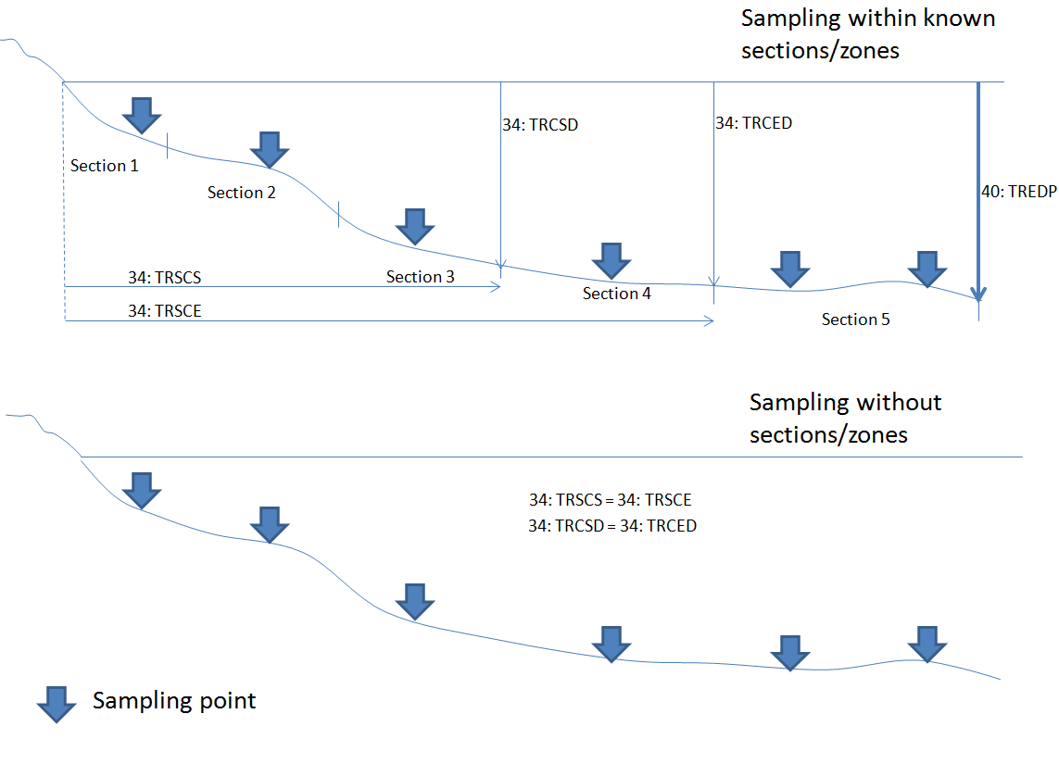

Example 2 Vertical Transect
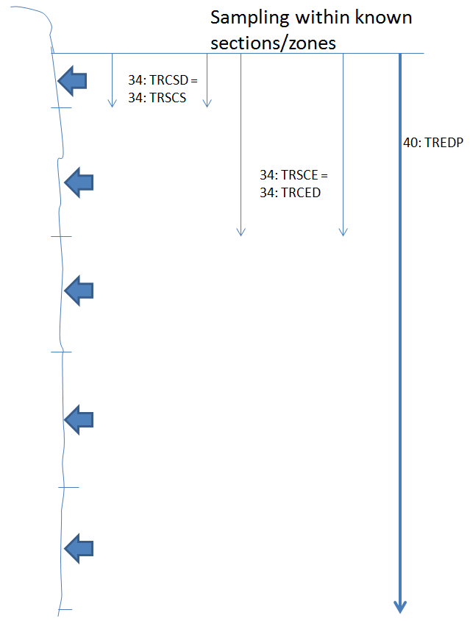
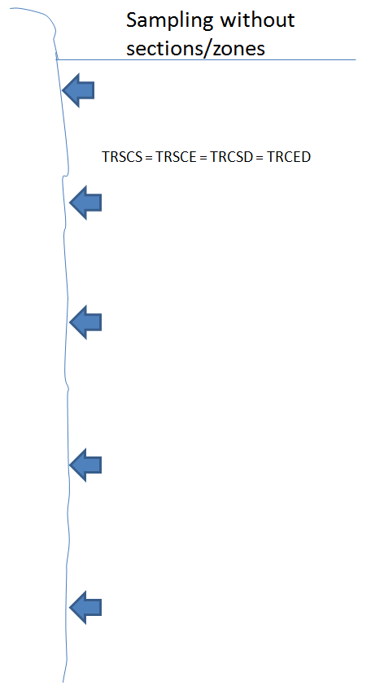

CHANGE LOG
ERF 3.2 was released for reporting data on 7 Jan. 2005. Change log started 2005-07-29
Edition date | Revision | Reason for revision
Release date 2005-01-07 | Version 3.2.1
2005-07-29 | Expand SMPNO field to 20
2005-08-10 | Intro to sample records
2005-09-05 | Multiple options possible (separate multiple entries with “~” (ascii 126)) for POSYS
2005-09-27 | Multiple options removed from SIZGL & SIZGW
2005-11-09 | “M” removed from CRMMB and note added to inform of ICCOD code changes. DATSU texts edited to clarify “mandatory” for OSPAR.  Sizes of fields expanded. Final values will be described in DATSU upon completion.
2006-01-10 | Added purpose of monitoring field “PURPM” in record 91. Changed version number to 3.2.1
2006-02-09 | Allow CW for PDMET and DEPHL
2006-03-29 | Char is allowed for STNNO and definition changed from “number” to “ID”
2006-05-23 | Clarified text for sediment grab SUBNO’s
Release date 2006-07-18 | Changed version number to 3.2.2  Record 38:  - Deleted SIZGL(sizegroup length) field in record 38  - Deleted SIZGW (sizegroup width) field in record 38  - Added SIZCL (sizeclass) field in record 38.  NOTE that the number of fields remain the same in record 38. SIZCL replaces the SIZGL field and checks will be added to DATSU to ensure correct usage between format versions.  Record 21:  - Added SIZRF (sizeclass reference list) in record 21.  - Added FORML (formula) field in record 21. | HELCOM PEG stated that fields are insufficient for reporting size classes of phytoplankton. New fields needed to meet PEG’s requirements.
2006-07-19 | - Web link to FORML  - SIZCL changed to integer  - RSRVD added to “blank” field in record 38
2006-08-01 | MSTAT can have multiple entries | Stations can have more than one point source impact
2006-08-31 | Removed italics from MNDEP/MXDEP | Italics are misleading - interpreted as a key
2007-03-01 | - In SMVOL, volume information changed from (liter) to specifying liter for PP, cubic meter for ZP and liter sediment for ZB.  FLVOL definition expanded to : “Calculated volume of water (cubic meter)”
2007-03-28 | - METCX can have multiple entries so allow “~” | Reduce amount of requests for chemical combinations in new RECO METCX codes.
2007-06-01 | - MESHS and SAREA in sampling method are now allowed for datatype PB | Data submitter has data to report.
2007-08-01 | - MUNIT reference to RECO was added in record 93
Release date 2008-02-27  2007-09-04  2008-01-17  2008-02-15 | Changed version number to 3.2.3  - PRFLG depth/pressure flag added  - STNNO was changed to TRANS ID to link to the 92 record.  FNFLA made mandatory for PB  Added Data Centre flag field  Clarified NODIS description | - Pressure needed for 3.2 data entering the Hydrochem database.  - Records 31, 32, 33 are now checked by DATSU. This required a field change.  Samples without fauna can occur for PB. ESD will not allow entry unless FNFLA is filled  Need to flag legacy data where errors or omissions in older data would otherwise prevent entry to ESD.  Data submitters do not understand this field which is a requirement for assessing fish survey data by WGPDMO.
2008-04-10 | WIRAN field opened for PP, and removed for ZB | Error corrected
2008-07-24 | Added reason for changes to change log table | For clarity
2009-04-27 | Added PP to STAGE in 38 record | Omission corrected
2010-05-28 | - Added PP to NPORT in 34 record and added “split” to definition  - Added PP to CPORT in 38 record and added “split” to definition | Clarified usage. For split samples only, i.e., splitting one bottle.  NPORT/CPORT unlikely for PP but could happen. Benthos more unlikely and field remains not active.
2010-06-14 | Enlarged SMLNK field from 2 digits to 3 digits. | Fish disease data need speed reported for each haul and they have more than 99 hauls per year.
2010-06-25 | SMVOL – added rPlankton | Omission for PP corrected.
Release date 2012-11-15  2010-2011 | Changed version number to 3.2.4  Quality Assurance:  - Added QA accreditation field to record 21  - Added QA accreditation organisation to record 21  - UNCRT/METCU fields now mandatory for chemicals | HELCOM MONAS 2012 approved  MCWG, HELCOM MONAS, OSPAR MIME
2011-03-09 | Support transect points/section information  - Deletion of 31, 32 and 33 record  - New record – transect record 40  - Deletion of fields in 34 record: MXVEG, SPVEG, RLIST – no data in database and order not changed  - Addition of fields for 34 record: PRSUB, TRSCS, TRSCE, TRCSD, TRCED  - In 92 record, field TRANS replaced with RSRVD so it can no longer be used  - ZB allowed as transect data | WKMDB specifications for phytobenthos transect data.
2011-03-09 | - SAREA “Sampler area opening” changed to “Sampler area including field of view” | WKMDB: The definition was confusing.
2011-07-21 | Description change for coordinates  - WGS84 recommended  - Decimal degrees now allowed | Request from OSPAR
2012-03-08 | Revise definition of R21:SPECI and link to RECO table VIVIT (In vivo/in vitro test) | SGIMC2011/WGBEC2012 expansion of field to include in vitro tests (Cell lines)
2013-03-01 | Edited 3.2.4 links to new web site locations
2013-06-21 | Added DTYPE ZB to R38:TRANS | Omission corrected
2013-06-24 | Added meters to definitions of PRFLG, TRCSD and TRCED | Clarification
2013-07-17 | Removed rOSPAR on CRMMB and CRMMV | OSPAR no longer requires these – now requires UNCRT
2014-02-19 | Correction of text:  From ‘Yes’ to ‘Y’ for Yes and  From ‘No’ to ‘N’ for No | Clarification
2014-05-21 | Correction of text:  LMQNT is only mandatory for some programmes and some chemicals – changed to R as this is controlled in DATSU | Clarification
2014-12-12 | Correction to CRMPE – added “weeks” | Clarification
2015-01-20 | R94:ICCOD made Mandatory | Originally a system was planned where 94:ICLAB could link to another database and get all ICCOD participation results for the lab reported in ICLAB. ICCOD was therefore not necessary if ICLAB was filled. This will not be done so ICCOD is now mandatory if the 94 record is reported. Record 94 is still optional.
Release date 2015-03-30 | Changed version number to 3.2.5  Litter record 36  SAREA in 20 record opened for CW  New fields added in 20 record: Observation height (OBSHT), Duration of haul (DURAT)  New field in 91 record: EDATE | Allow reporting of litter in all data types and as a separate data type  New fields needed for passive sampling data in seawater (CW).
 | LTPRP multiples allowed | Descriptions can be colour/shape/size etc.
2015-08-01 | Diagrams edited: litter in biota to be reported in 10 record with PARAM starting with “LT%” | Clarify difference between reporting litter (ex. microplastics) found inside organism and litter gathered in same net (macrolitter)
2015-08-11 | Fields DUREX and ESTFR added to the 20 record sampling method record | Needed to support MCWG2011 mandatory requirements for passive sampling
2015-10-19 | Allowed METPT for all data types | Labs report the field and errors are first found when data are prevented upload in DOME
2015-11-11 | Field ESTSR changed to ESTFR | Conflict in database with legacy code ESTSR
2015-11-20 | Opened SEXCO for zoobenthos data | Request from submitter for easier mapping
2016-01-21 | Added field QFLAG to record 36 for litter data | Request from submitter who says weights are often less than scale’s capability
2016-01-21 | Clarified SAREA. | This field is data type dependent but these definitions are not found here. See FAQ document.
2016-02-10 | Corrected RECO link for PURPM | Was corrupted
2016-02-25 | Added mCW for DEPHU/DEPHL | Clarified that Depth is Mandatory for most parameters. Exceptions are effects parameters PNR and MORT%
2016-03-17 | Changed MAGNI description to Total Magnification | Total magnification – ocular, objective, plus base. Requested by HELCOM indicator producers
2016-03-17 | MNDEP and MXDEP mandatory for HELCOM | Requested by HELCOM indicator producers
2016-04-30 | DURAT expanded to Duration of haul or sampling | Field can now be used for Beach litter

